**CS408: Incremental and Regression Testing**

**Team members:** Trevor Neidlinger (tneidli@purdue.edu), Dan Hipskind (dhipskin@purdue.edu ), Morgan Kaehr (mjkaehr@purdue.edu), Ben Kahlert (bkahlert@purdue.edu), Tianchi Xu (xu878@purdue.edu)

1.1

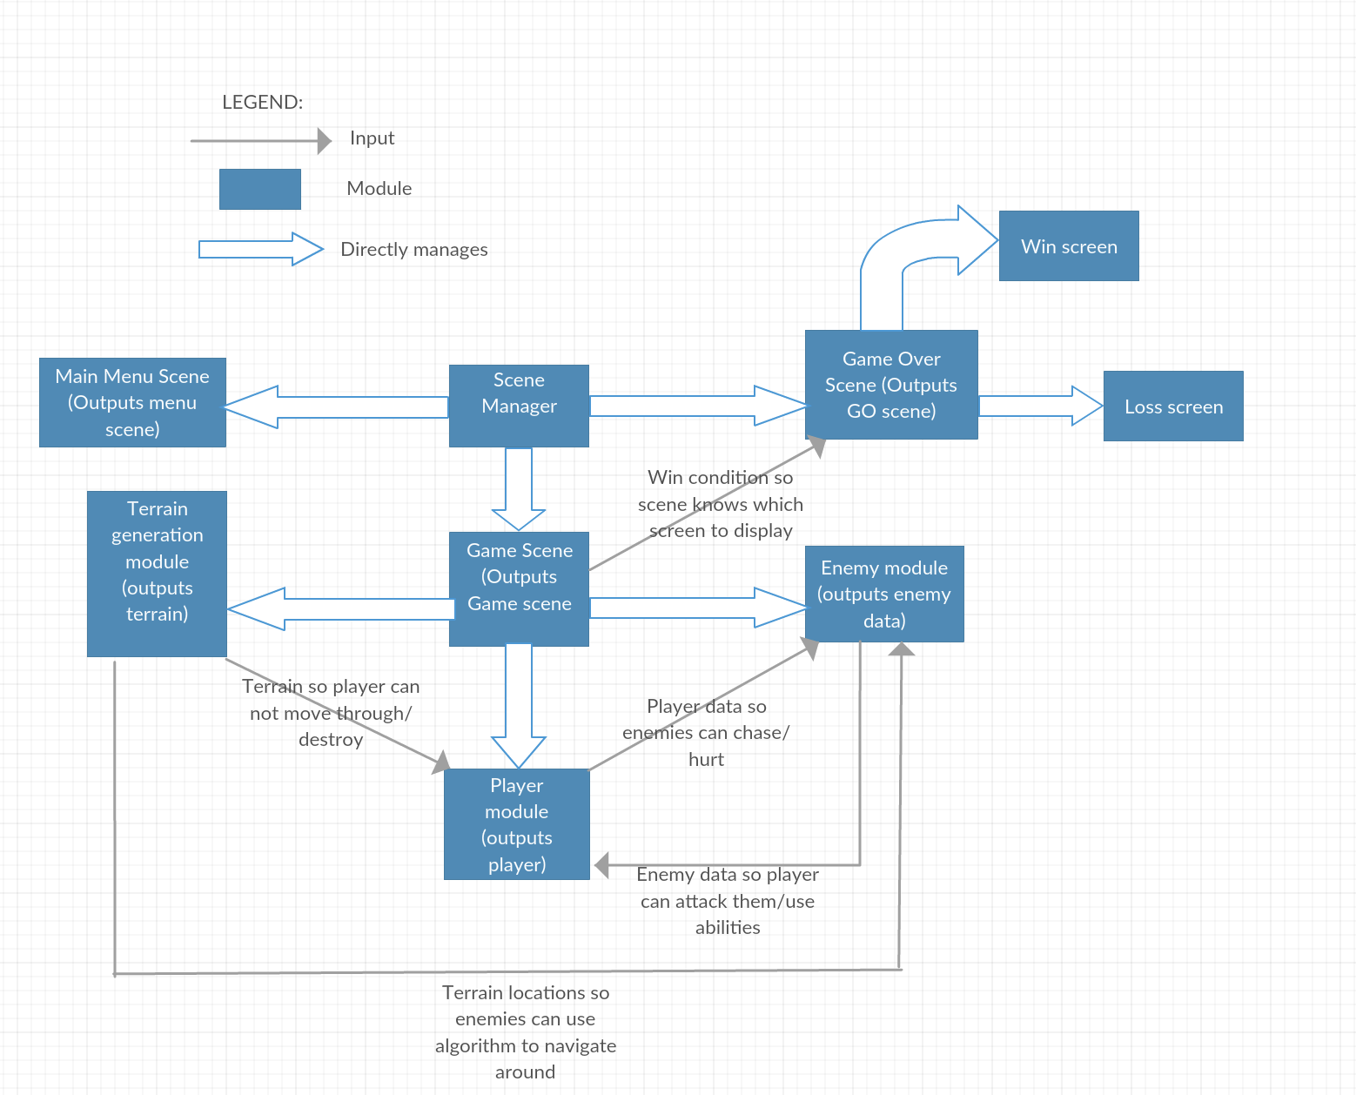

1.2

We choose to use the bottom-up testing method because each team member developed some specific functions related to the game. Test conditions are easier to create for each of us since we are testing a unit that we are responsible for. In addition, test results are easier to observe in this way.

2. Incremental and Regression Testing

|  |  |
| --- | --- |
| **Module** | Main Menu Scene |

**Incremental Testing**

|  |  |  |  |
| --- | --- | --- | --- |
| **Defect No.** | **Description** | **Severity** | **How To Correct** |
| 1 | Application should not crash when clicking on play. | 1 | Create the menu screen separately from the game screen. |
| 2 | After lose game screen returns to menu the play button would crash the game. | 1 | Reset all of the variables so the game will reset itself properly |

**Regression Testing**

|  |  |  |  |
| --- | --- | --- | --- |
| **Defect No.** | **Description** | **Severity** | **How To Correct** |
| 1 | Fixing application crash caused game to display to not be functional. | 1 | Rearrange files and how scenes get called |
| 2 | Resetting the variables would sometimes cause the enemies to not properly move. | 2 | Changed how the variables would be reset. |

|  |  |
| --- | --- |
| **Module** | Scene Manager |

**Incremental Testing**

|  |  |  |  |
| --- | --- | --- | --- |
| **Defect No.** | **Description** | **Severity** | **How To Correct** |
| 1 | When initially moving code from one file into separate files for scene managing game wouldn’t correctly load. | 1 | Changed how files were imported. |

**Regression Testing**

|  |  |  |  |
| --- | --- | --- | --- |
| **Defect No.** | **Description** | **Severity** | **How To Correct** |
| 1 | After clicking on play button the game would crash initially. | 1 | By changing the way variables were declared. |

|  |  |
| --- | --- |
| **Module** | Win Screen |

**Incremental Testing**

|  |  |  |  |
| --- | --- | --- | --- |
| **Defect No.** | **Description** | **Severity** | **How To Correct** |
| 1 | Game would get frozen when retry button was selected | 1 | Reset all of the variables involved in the game so that the game state is started over again. |

**Regression Testing**

|  |  |  |  |
| --- | --- | --- | --- |
| **Defect No.** | **Description** | **Severity** | **How To Correct** |
| 1 | Fixing the frozen game when resetting the variables would cause enemy movement to be wrong. | 2 | Changed the way the variables were declared so they could be reset properly. |

|  |  |
| --- | --- |
| **Module** | Game Over Screen |

**Incremental Testing**

|  |  |  |  |
| --- | --- | --- | --- |
| **Defect No.** | **Description** | **Severity** | **How To Correct** |
| 1 | When enemies touched the player the loss screen would not properly display. | 2 | Changed how the hit boxes of players and enemies interacted with each other. |

**Regression Testing**

|  |  |  |  |
| --- | --- | --- | --- |
| **Defect No.** | **Description** | **Severity** | **How To Correct** |
| 1 | When fixing how the player’s and enemies interacted with each other it changed how they interacted with the environment | 2 | Changed the way the hitboxes of the environment worked to be the same as players and enemies. |

|  |  |
| --- | --- |
| **Module** | Loss Screen |

**Incremental Testing**

|  |  |  |  |
| --- | --- | --- | --- |
| **Defect No.** | **Description** | **Severity** | **How To Correct** |
| 1 | Game would get frozen when retry button was selected | 1 | Reset all of the variables involved in the game so that the game state is started over again. |

**Regression Testing**

|  |  |  |  |
| --- | --- | --- | --- |
| **Defect No.** | **Description** | **Severity** | **How To Correct** |
| 1 | Fixing the frozen game when resetting the variables would cause enemy movement to be wrong. | 2 | Changed the way the variables were declared so they could be reset properly. |

|  |  |
| --- | --- |
| **Module** | Game Scene |

**Incremental Testing**

|  |  |  |  |
| --- | --- | --- | --- |
| **Defect No.** | **Description** | **Severity** | **How To Correct** |
| 1 | Dropped items are too big and resize method doesn’t adjust the collision size | 3 | Modify sprites to correct size |
| 2 | Player can’t pick up dropped items because of the collision | 2 | Change the detecting mechanism from collision to overlapping |
| 3 | Item doesn’t disappear after the overlapping between player and the item | 2 | Deconstruct the item object after the overlap |

**Regression Testing**

|  |  |  |  |
| --- | --- | --- | --- |
| **Defect No.** | **Description** | **Severity** | **How To Correct** |
| 1 | Different items should give player different attributes | 2 | Give each item an unique id |

|  |  |
| --- | --- |
| **Module** | Terrain Generation Module |

**Incremental Testing**

|  |  |  |  |
| --- | --- | --- | --- |
| **Defect No.** | **Description** | **Severity** | **How To Correct** |
| 1 | Enemies did not know where terrain was when terrain was implemented | 2 | Pass the terrainMatrix (containing terrain coordinates) to enemy module. |
| 2 | Player was able to move through terrain (unintended) | 2 | Add a collision function with wall/player was missing a callback function |

**Regression Testing**

|  |  |  |  |
| --- | --- | --- | --- |
| **Defect No.** | **Description** | **Severity** | **How To Correct** |
| 1 | When linked with the Graphics module, terrain loaded on an incorrect grid. | 2 | Change variables when initializing terrain in graphics |
| 2 | Enemies get stuck on terrain when moving | 2 | Alter the movement algorithm of enemies in the enemy module |

|  |  |
| --- | --- |
| **Module** | Player Module |

**Incremental Testing**

|  |  |  |  |
| --- | --- | --- | --- |
| **Defect No.** | **Description** | **Severity** | **How To Correct** |
|  | Player instantly detonates mine when it should have time to arm | **2** | Switch mineActive incrementer outside of the cooldown conditional |
|  | Player moves to last clicked spot instantly after teleporting | **3** | Set player movement speed to zero so that he will be still after teleporting |
|  | Player triple teleport R ability would not reset cooldown if recast a fourth time | **2** | Reset a variable called numCharges back to zero once it hits 3 charges used |

**Regression Testing**

|  |  |  |  |
| --- | --- | --- | --- |
| **Defect No.** | **Description** | **Severity** | **How To Correct** |
|  | Fixing player teleportation cooldown problem caused cooldown to always be zero | **2** | Create separate conditional statements for each variable |
|  | Fixing player moving to last clicked spot instantly after teleporting problem caused player to teleport on next click rather than slowly moving | **3** | Set new player position to teleported location for movement |
|  | fixing player instantly detonating mine problem cause mine to never go off | **2** | Add conditional to make players mine wait in a separate statement before arming |

|  |  |
| --- | --- |
| **Module** | Enemy Module |

**Incremental Testing**

|  |  |  |  |
| --- | --- | --- | --- |
| **Defect No.** | **Description** | **Severity** | **How To Correct** |
| 1 | Enemy did not properly follow player when given player input | 2 | Correct A* searching algorithm |
| 2 | Enemy did not attack player when near | 2 | Adjust collision radius for enemy and player |
| 3 | Enemies sometimes went off screen attempting to follow the player | 2 | Adjust game border size in the game module |

**Regression Testing**

|  |  |  |  |
| --- | --- | --- | --- |
| **Defect No.** | **Description** | **Severity** | **How To Correct** |
| 1 | Enemy animation should play when moving in the graphics module | 3 | Add animation function in enemy movement function in the graphics module |